Supplementary Material
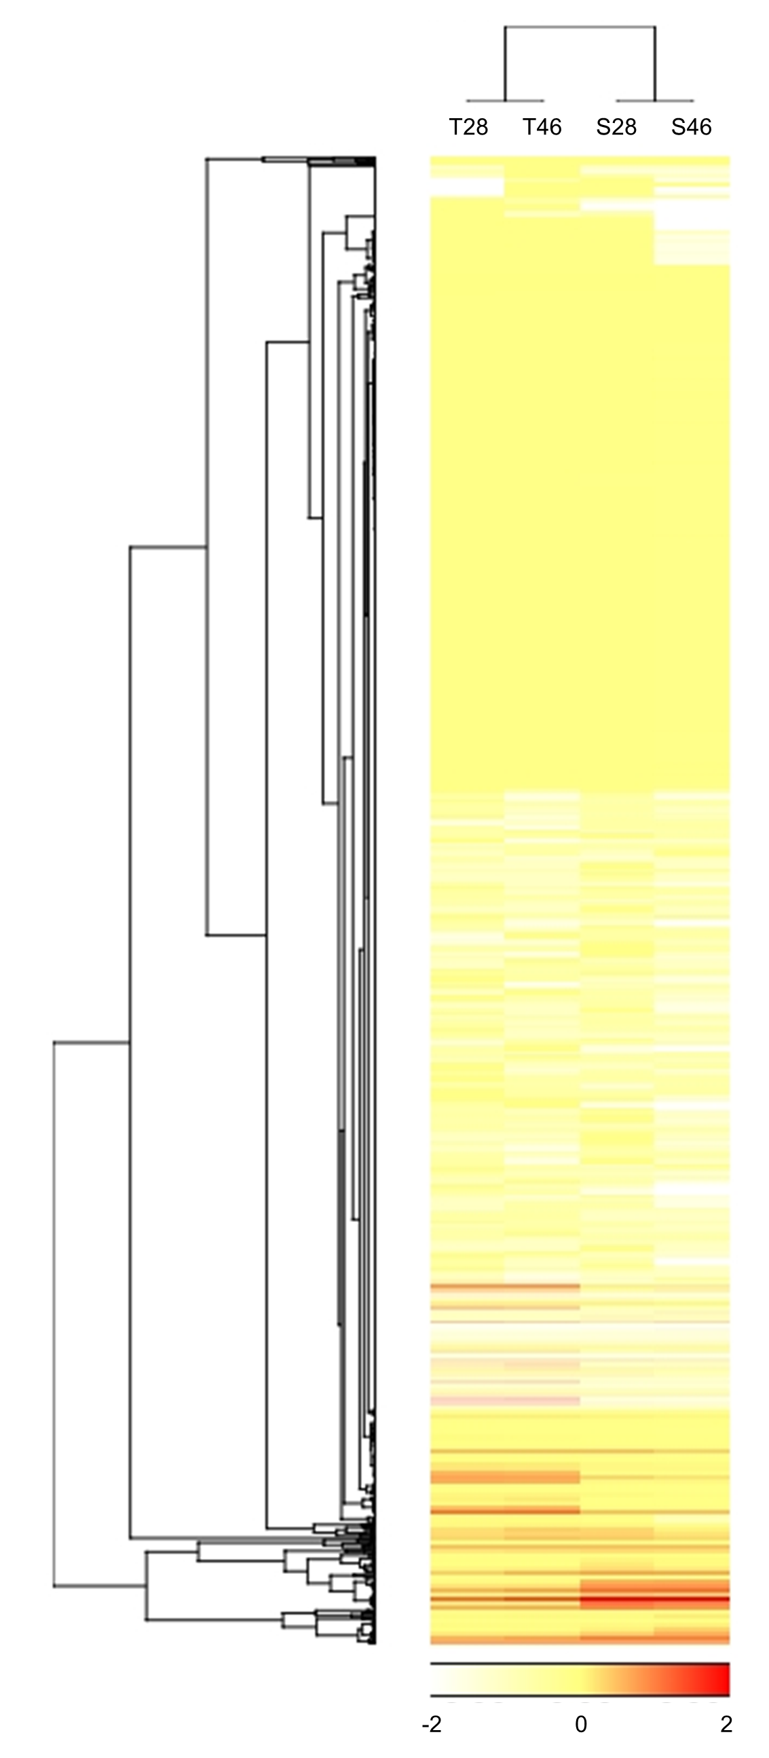
Figure S1. Hierarchical clustering analysis based on whole tissue and serum miRNA profiles obtained from 28- and 46-week-old L2-IL-1β mice. Twenty upregulated and 44 downregulated miRNAs in both tissues and sera in 46-week-old mice compared to 28-week-old mice were selected; T28, tissue miRNAs obtained from 28-week-old mice; T46, tissue miRNAs obtained from 46-week-old mice; S28, serum miRNAs obtained from 28-week-old mice; S46, serum miRNAs obtained from 46-week-old mice.

